**Communications Engine**

The communication engine is responsible for processing incoming messages from outreach and handover SMS or email messages to communication vendors through their API endpoints. Once the communication vendor accepts messages, it's their responsibility to execute the last hop of the engagement, which is to send an email or SMS to a patient of a provider or facility.

Communication engine has two main capabilities

1. Send messages out to communication vendor (outbound messages)
2. Process incoming status messages from communication vendor (inbound messages)

Solution design objectives

* Develop communication engine as a **W**atson **H**ealth **F**oundation common asset
* Adhere to the design guidelines listed in Watson Health Service Framework
* <https://test.cloud.ibm.com/docs/healthcare-framework?topic=healthcare-framework-getting-started>
* Design a solution leveraging cloud native architecture
* Maximize use of serverless to gain the benefits of consumption based pricing in cloud

Business, compliance and security objectives

* Solution to support multi-tenancy

**RELEASE 1 - Outbound message workflow**

Following is the high-level workflow of outbound messages.

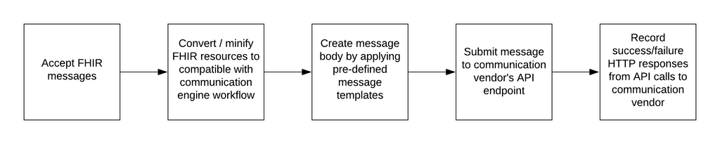

Below digram presents the proposed solution design for the outbound message workflow of the communication engine. Goal is to design the communication engine to be independent by removing the data or functional knowledge of Phytel engagement platform.

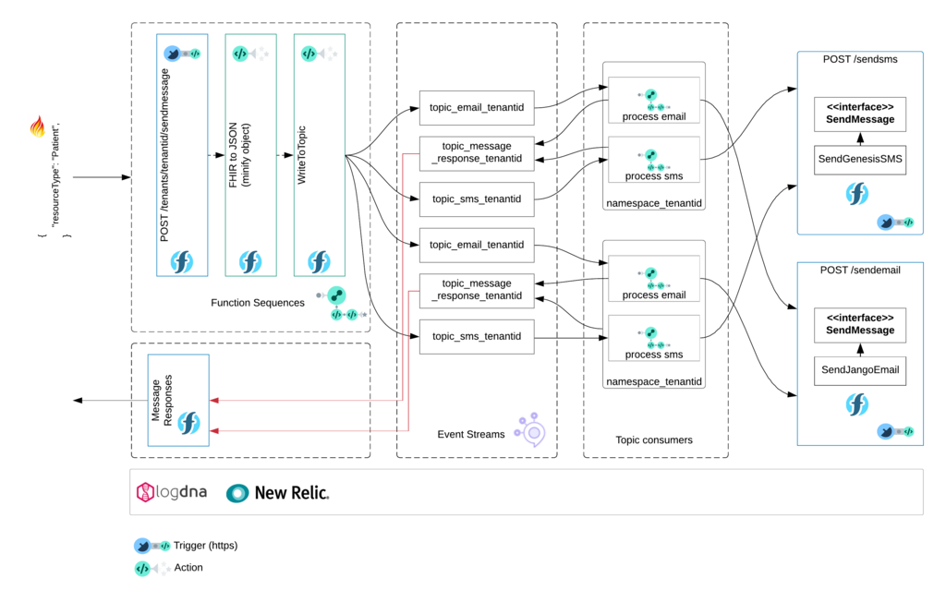

My questions

FHIR on wire

Communication engine expects a FHIR resource type "Patient" as the input to initiate the outbound message workflow. Since FHIR Patient specification does not contains all the information required by communication engine business logic, several custom extensions are introduced to the "Patient" resource type. Populating values to custom extensions are done outside the communication engine and it will be detailed in the responsible component's design document.

Following is a sample json payload of FHIR resource "Patient" with custom extensions.

**{**

* **"resourceType": "Patient",**
* **"id": "ddf5ae5c-5646-4a76-9efd-f7e697f3b728",**
* **"extension": [**
* **{**
* **"url": "http://example.org/fhir/StructureDefinition/message-templateID",**
* **"valueUuid": "3c9a0fe6-156a-4190-ae6b-ebb6f07e52cf"**
* **},**
* **{**
* **"url": "http://example.org/fhir/StructureDefinition/patient-careGaps",**
* **"valueString": "A-001,B-001,C-001"**
* **}**
* **],**
* **....... remaining attributes in FHIR resource ......**

**}**

|  |  |
| --- | --- |
| **Extension** | **Purpose** |
| message-templateID | GUID of the pre-defined message template |
| patient-careGaps | List of care gaps identified in cohorts |

Reference : <https://www.hl7.org/fhir/extensibility.html>

Process email & process sms

Following is an expanded view of the function sequence of "process email & process SMS," which is responsible for selecting the correct message template from the template store and generating the text or HTML of the message body. Creating and configuring message templates are done outside the scope of the communication engine.

IBM Cloud services used in proposed solution

|  |  |  |
| --- | --- | --- |
| **Service** | **Billing** | **Notes** |
| IBM Cloud Functions | $0.000017 per second of execution, per GB of memory allocated | <https://cloud.ibm.com/docs/openwhisk?topic=cloud-functions-limits> |
| IBM Event Streams (Enterprise for production) | $12.50 USD/Instance-Hour | <https://cloud.ibm.com/docs/services/EventStreams?topic=eventstreams-plan_choose> |
| IBM Activity Tracker with LogDNA | $3.00 USD/Gigabyte-Month |  |

Application performance monitoring

Proposed list of alerts to configure in APM platform

* Total number of errors (code other than 200 OK) from API call to service provider
* List of errors - invalid tenant id, number of malformed FHIR messages